Festivals, prawns, verse and deckchairs
Angel C. Dye meets poet Matt Chamberlain
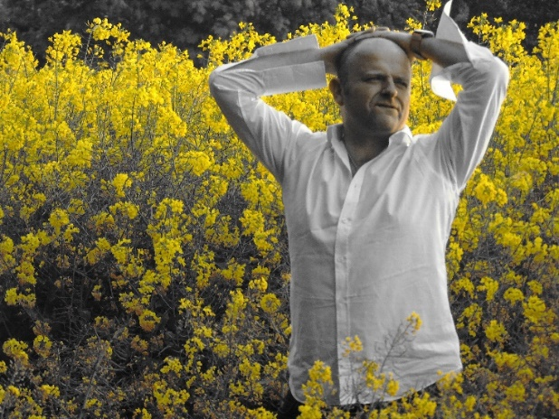
What do poets wear to interviews? Maybe Lazarus-style bandage over eyes (as in Matt Chamberlain’s Bowie-inspired ‘I Can’t Look’ YouTube video, a tragic story of submission by the down-beaten)? The tale behind many closed doors, given a new twist: just don’t look.
I am not sure if I can look. Perhaps foolishly, before this meeting, on the strength of his poems, and imagining I liked the heart of the man, I recklessly decided Chamberlain was to be something of a star turn at a Literature Festival I am organising. Unsure whether I will be able to go back on my earnest plea if our interview is a disaster, I wonder will I actually like the man who walks the pages of a book I enjoyed? Will he match the man I imagine I saw in the ‘shadowed gaps’ of his poems? Will he arrive in ‘Harry Hill’ shirt as seen in one of his videos (no, please no, not on the beach!), or rock t-shirt or dapper suit and waistcoat?
This man, if one watches his videos, is a chameleon. He inhabits his roles by becoming the character so entirely that his actual face changes. This face never looks the same: elfin, hobbit-like, inviting, warm, grimacing, intense blue-eyed happy daddy, thug, average Joe. A face with easy smiles but in a second the atoms rearrange, collide and. . . is that gloom I see on day release? It is a putty face that can stretch into anything. It gives his pieces power and makes the audience really believe him. In ‘The One Who Hurt you’, the soul seeking acquittal is so pained one just wants to become God and let Chamberlain off the hook, so real is the performance.
And therein is the absolute lie - performance. Because this is not acting, or pretentious art, this is Chamberlain’s poems just clawing their way out, pouring their way out. If you haven’t seen him perform, then please do as soon as possible. His is not the zappy, rappy rhyme-with-power chronicling all social ills; this is a poet who etches life’s dramas and injustices with the most deft and delicate touch of the pen. The poem, more fragile on paper than in the lungs, takes on new layers of meaning as Matt himself works through the complexities of what it means and challenges us all to consider the words; the subtle slice of a buttery verb; the whip of a noun used as an adjective; all strung into images, visceral, yet gentle too.
But Chamberlain doesn’t want to be let off the hook. As the blurb says on the back of his third book, Lowering Awareness, he wants to minimise the dramas, embrace them, draw them in, relish crumbs, and celebrate the glooms and joys that make us human. Bowie said it de-humanized him when people believed he actually was those characters. Chamberlain is himself in all he plays. He is aggressive and tender all at once. Pathos and poignancy and passion and poison slide together in the same seemingly easy sentences. Know this: every word is weighed and measured. He says they are just ‘spewed’ out but I think it is more that the trained linguist naturally knows the grammage hiding in each word and knows exactly and intuitively the counterweight.
Matt Chamberlain chooses the Kent countryside and Whitstable beach as the backdrop for our interview. Perhaps a man who commutes daily on dusty trains feels choked by life’s grind and grey? Escaping to the countryside whenever he can to breathe green and yellow and pink and blue back into his soul? Here, he ambles in a . . . oh no. . . heck. . . is that a ‘Harry Hill’ shirt? On the beach? No! Relief! He draws closer: untucked, collars normal size, cuffs rolled loosely, smiling huge smiles with warm bear hugs. A man who loves Nature, the song of the sea behind him, the paint box sky and the smell of salt downwind remind me of the flavours of his poems – ‘anger manhandles rage’ and ‘love the last one standing’ come to mind as I see him small then large against the sky. It was the Apostle Paul who first claimed ‘Nature is a language, can’t you read?’ and Chamberlain certainly sets many of his poems against beautiful backdrops, like the breathtaking, prize winning ‘Stained Beauty’ about murders upon the moors, and ‘Solace’ where he ‘counts his rocks’. Or ‘Spiced gold branches’ in a poem published in Wandering Words, an online podium through which selected writers celebrate local environments.
For a while we don’t speak much and just drink in the air. We slouch down into blue striped deckchairs against the wind. ‘Oh, yes please!’ he says, so Northern and nostalgic, tea in hand, and tickled pink to learn that Amazon says ‘people who bought Alan Bennet’s diaries also bought Matt Chamberlain’s Lowering Awareness’.
Now why do I want to meet someone so fiercely private? What on Earth could I possibly get out of him? Someone had tipped me off that he wears his heart on one sleeve and a padlock on the other. I want to see if it is true. Is he really as curmudgeonly and gloomy as he purports? Is he really so private that you could see his bleeding heart, tuck it back in and stitch him up and read all the words drowning in his spilled blood, but God forbid you see his bathmat or the colour of the towels, I wonder? “Oh, I like that about the bathmat!” he exclaims. So I can bear to look. I want to know what is he doing next, and where we can see him? I want to see if the conflicted man I thought I met inside a book will see the sun or perpetually walk with a thorn in his side. I want to know whether, like in the poem ‘Things Pass’, ‘daylight burns holes in (his) heart, and sizzles the brain, till it knows that none of this can be paid for with feelings, (when) the longing for night only grows’.
I sense a fightback. As the blurb on the back of his second book ‘Binge Thinking’ says, romanticism is fighting against pragmatism. Chamberlain casts himself in his biography in Confluence magazine as an apprentice romantic poet and human. Not in the strewing of roses over London’s grey platforms but in allowing us, through feasting on feelings, or subduing the senses actually to feel. To feel all feelings, to have no shame in feeling them all, and for savouring and even cloaking gloom and remorse and fastening them tight at the neck. This is vampire romanticism, gritty but tender, sweet but bloody, sticky, viscous, sharp, soft and messy (like the fruit crumble in the title of his debut book), daring ourselves to feel deeply, to court intensity. ’The alternative is to atrophy’, he says.
Whitstable, hot bed for oysters, lobsters and prawns. He tells how he can never trust a prawn. I am with him on this observation, borrowed from Victoria Wood – Chamberlain clearly adores her. She may not be known as a poet but her deftness, her acute, simply expressed wry observations paint pictures that stay with one for life. A prawn treading water in sewage – the image is so clear in my mind. And I have never eaten once since. Such is the power of a few simply dressed words tossed with mild vinegar. Chamberlain explains how such economy with words influenced his own style. There are elements of joy in his work and sprinklings of humour. The humour is mostly portraits of others and his deep appreciation of them, rather than him offering his own belly laughs. Considered a serious person, he says that this is probably the lightest he has been in years, that ‘this is the young Matt now’. Some of his performances are comic, and poems in the tongue of his homeland paint beautifully genial portraits of his grandparents. I wonder how well his work would go down in Wigan. I wonder whether the anonymity, the release from cultural expectations lets one be freer? But I don’t ask him.
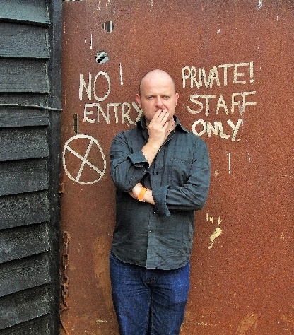
He has found in Kent a cultural richness that was unexpected, being cut off from the main pulse of London. On paper Medway has all it needs to be a fabulous place: cathedral, restaurants, glorious artists and musicians, a bustling ‘scene,’ a big muddy working river, views, period housing, great schools, art colleges, universities but somehow it is less than the sum of its parts. These towns have a rich heritage of music and arts. The touch paper of the Medway Poets in the 80s never fully fizzled down. Pockets of magma have re-ignited in seams along the medieval high-street that shy shirks the riverbank. Here, poets stanza together, musing, laughing and celebrating the joys and tragedies of life through the spoken word. Wordsmithery, a literary agency, hosts events to showcase Medway’s Moet at its Roundabout Nights event where Chamberlain is an acclaimed regular and special guest on 8 June. Not everyone will love such wrought performances but Chamberlain says he looks at himself from outside of himself as he performs and gets a sense of what the audience sees. Seeing him live at another local event, Inspirational Nights, I believe that as a result of such reflection his performances are less contrived, less ‘poet voice’ and more authentic for the control. ‘Many would not agree with you’, Chamberlain observes. ‘All I can do is perform my poems wearing my heart on my sleeve. Some won’t like it but, on past experience, some will’. He sits with an arm over his head, an unusual position but it seems to be default position. I wonder if it denotes a vulnerability, a subconscious protective mechanism. So who would not like your poems?
‘Lots of people don’t like them. And lots more would dislike them if they had been given the opportunity to. I don’t think there is any limit to the amount one can be disliked if sufficient effort is put in. But a few people do like them. And that’s actually amazing because, apart from close family, nobody actually has to! Everybody has got better things to do than read or hear my poetry, let alone praise me for it. So when somebody does, I love them very much.’
He talks of Bowie’s 1995 album ‘Outside’ – another obsession – and how the process of its creation was so spontaneous, and immediately reflexive. I get an image of a shyly hedonistic, language-loving northern boy in Wales, the sounds of Bowie and Mancunian musicians and comedians giving him the permission to be who he wanted to be, who he already was, intense, cool and even brittle, and think such spontaneity must seem strange to a linguist used to analysing and measuring. Throwing words up in the air and creating a collage of poems? Could Chamberlain take such risks? It seems to me that he can conjure magic quite easily and some of his more immediate poems juggle humour and pathos. ’Thank you, most kind’ he says.
He enjoys juxtaposing two angles and exploring connections, ‘the sheen upon them’. He says there is no formula, at least not a conscious one. Chamberlain and Spreken’s new collaboration, entitled ’One Man’s Trash’ is a project with a randomised element in which, he says, ‘words had to be placed’. He found this harder than writing poems about himself and his experiences. It must be harder to convey thoughts and feelings about things that actually mean nothing to you? ‘Those little mundane things in ‘One Man’s Trash’ don’t mean nothing to me, though. That’s the point. They are things that may have been overlooked previously but the idea was to look at them and think about them and eventually see something in them. Things like a mark on masonry or a pile of dirty dishes did suddenly mean something. So, yes, that project was harder because of the having to look. But once you’ve looked it isn’t harder. And it was so satisfying’.
Victoria Wood said she stayed true to the idea that people can have a day in their lives that is very important and if they can reconnect with that day, with the people they were then, they can revive their emotions. Romance is not dead. By romance, I think Matt, like Shelley, means exploration of nature and place as well as love and loss. Many of Chamberlain’s poems are ‘bugs in amber’, allowing exploration of something that happened once upon a time but the themes are universal and can be accessed at any time. Life seen through a glass, darkly. Reviews suggest that these poems grab people’s hearts, frame human experience. Is that not the essence of good poetry? ‘Poetry has changed the way I see things. I was always the over-sensitive sort and being a poet hardly makes you less sensitive! But in a funny way it has broadened me out, made me a bit less ‘black and white’ about things. It makes you look at things from different angles and for me that has been a good thing’.
Chamberlain says he prefers poems that are a ‘delicate starter,’ giving a delectable taste but leaving him wanting more for the main course. He wants poems to flirt with him but not ‘instantly move in and leave all their possessions on the front lawn.’ He modestly amends this – ‘I don’t want to say what good poetry is, only offer my opinion of it’. For such a strident performer, he is gently self- effacing, careful to frame words so they uplift. In life as well as poetry he ‘likes to weigh words carefully’.
He says he likes the ‘music of melancholy, not misery but melancholy’. There is always beauty curling at the edges of even the most deprecating poem. ‘Sorrow, true sorrow, needs to make a comeback’ he thinks. He says he would ‘fall over (his) own breath and create a new language to say sorry’, and he claims ‘there is nothing he will not forgive, except his heart’ so he is not impressed with ‘a modern preference for shrugging things off and moving things on’. He can be suffocatingly serious but also laughs at himself a lot. Sitting in our deckchairs on a cold blowy beach, he suddenly laughs boomingly at the comedy of his being ‘wrongly’ dressed for the beach. Which is odd. A quilted anorak is somewhat incongruous when slouched in a sagging deckchair but it’s hardly hilarious. All supposed vanity is blown away yet he is very poseable and amenable and again shows that interesting chameleon quality, transmuting before a lens into versions of himself. He is a lot like the broken window ‘crystals’ diffusing light in his poem ’Piccasso’s Crystal Gems’, it strikes me.
He tells me he has a ‘charmed life’ yet is ‘dripping with melancholy. Even in celebratory poems there is a sighing half smile. I love the rhythm of sad themes.’ I feel slightly glad and also sad that I did not know his younger character, bleak with brittle intensity. His mood is infectious, I note. ‘I hope that doesn’t mean I make people feel sad’ he replies. I dispute this but he does seem to straddle worlds of joy and gloom simultaneously, seeming to access the underworld easily, making it palatable and making people feel they can share their darkest moods. There is a genuine warmth, despite a disparaging-ness that may mock. He says he wants to ‘be the whole scene’ but I find him to be incredibly generous about others’ talent and agree with him when he says he is ‘not too bunged up to champion others’.
He seems to exude a mixture of extreme guardedness and extreme openness. Sometimes he is generous with information and still manages to make clear that it’s not really any of your business. Private and occasionally petulant, he sometimes cunningly fails to answer and sometimes blatantly so. ‘We can discuss bleeding hearts till the cows come home but don’t you dare rifle through my sock drawer.’ His poems do open the window onto his life. Some are too painful to watch or read. It feels voyeuristic to do so – ‘cruelty the entrée to soft soap’ makes me scream too much information! He declares that ‘these walls have fears,’ and although the walls are removed in the poems, the net curtains are (I am glad to say) still slightly opaque. In another recent interview, he seemed fussy about the name of a colour, but it all produces humour. One wonders if he likes to just be in control of the information feed. He wants people to discuss every syllable of his poems, roll them over their tongues, but he will ‘commit actual murder if someone tweets my breakfast’. Like Alan Bennet says, ‘freedom of expression is fine only if it is controlled.’
He can be endearingly pedantic. When I apologise for taking his time, he takes control by saying ‘no I chose to give my time, only I can give it’. He is willing to give time to others, supporting the Artists’ Quarter at this summer’s Vicar’s Picnic Festival. He says he is not altruistic but poetry is. I agree – I think poetry is sharing of yourself for little or no return and it leaves you wide open. But he seems to revel in that. Fiction is fiction and we know Ziggy Stardust did not go to Mars, but Chamberlain’s poems . . . well if he writes about it, then it happened.
I viewed Lowering Awareness as a confessional altar; a place for penance for being human. Auden said ‘we must love or die’. Parable art which shall teach men to unlearn hatred and learn love. This theme gently kisses the shadowed ground in the romantic, confessional poetry of Matt Chamberlain. He finds his sources in the minutiae of every day and brings them into sharp relief for us to savour. He voices what many of us do not dare to discuss or reveal unless over a gossipy wine with girlfriends. ‘I like giving a name to how things feel, shouting insecurities rather than drowning them out’. When asked, he says God would ‘love his poems’ hastily de-blaspheming this utterance by explaining the pay-off between God-given ability to err on the one hand but to recognise and redeem on the other hand. Although none of his poems shout about morality they do all explore injustice and suffering ‘in a small way’ and make no secrecy of imperfection – especially not his own.
He describes his book as a stroll: ‘Once you have stopped off for a picnic, paddled in the river, gandered at the view, eavesdropped the conversations of passers-by you’ll forget where you were meant to be going. Which is good because it was never meant to be a walk to somewhere in particular.’ Very nice, but I think he fails to see the darker themes that emerge when the strange alchemy occurs by fusing these many different aspects together. The book starts and ends with self -portraits, the first suggesting a re-discovery of self. Then we go on a journey he describes as ‘redemptive’. Yet it all ends with him apparently refusing to redeem himself! Paradoxical and contradictory, I suspect these poems took the poet on a journey he still has to discover for himself.
He says firmly that he has no imagination. This is hard to believe when he wears such flamboyant clothes (‘Ah, but I wore shocking pink shirts undone to the waist in my youth’) and writes beautiful words, does lovely films, both in character and as himself. On closer scrutiny, nothing is fictitious, nothing hints at other worldliness, all is tangible, all is there. ‘Poetry for me isn’t something fanciful or other-worldly. Readers dress the words with their imaginations.’ Poetry’s power has simplicity and being human at its root and he excels at this: the real, the true, the actual. In some ways his next book, One Man’s Trash – born when he and his co-author ‘wrote themselves into corners’ – is no different. In the pre-publication segments I have read, I see a heightened celebration of the mundane and the ordinary; minutiae of life lifted up for public scrutiny.
His new appointment as Festival Laureate at this July’s Vicar’s Picnic festival in Yalding, Kent gives him the opportunity to engage with a wider audience. His short films promoting the Vicar’s Picnic have already had 3,000 views, quite a lot of exposure for a private man. And this ties in beautifully with his stated wish to ‘have thousands of fans, standing on street corners discussing the weight of each syllable’. He adds, I want people ‘to leave with my words on their lips’. The films show him picnicking, dancing, prosecco by his side (he seems more of an ale man to me), suddenly not so shy or private. When asked about the relevance of poetry today, he gets suspicious of the concept of relevance and says intrinsically poetry has ‘no more and no less relevance than, say, custard – but as an art form speaks to those that have ears to hear it’.
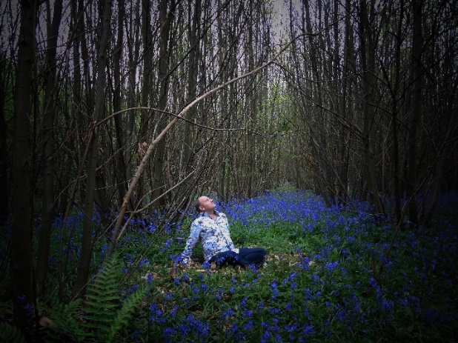
At the festival he will mill the crowds, collect anecdotes and string them into poems. He will perform and watch other poets in the Artists’ Quarter. He will dance like Verbenas swaying in the wind. If his poems were flowers they would be these, he says. ‘Delicate, lilac coloured and unassuming flowerheads but on stems that sway in amongst the more vibrant flowers, creating a layered feel and making me smile.’
I mentally calculate - is he right for my new festival? I realise I really want him to do it. I want him to bring an orchestra of words, the poignant running into the comic into the nostalgic into the romantic. I think he could set hearts ablaze with his poems. But he hasn’t brought it up. Perhaps he doesn’t want to do it. I’ve learned that he’s quite quick to say no and I really don’t want to push it. So I don’t ask.
He leaves before dark, ‘as the pastel day grows up’. This man ‘who bubbles up at sparrow squabbles’ and ‘only rents corrosive heartburn tears’ is going home. He looks exhausted – it must be tiring being so many people. He does seem to have walked straight from the pages of his books. Honest and enigmatic, cheery and sad, profound yet earthy. Right now he seems like he already has one cheek on the pillow so we hug goodbye. ‘I do like hugs’ he says. As I watch him drive off down unlit, potholed country lanes I make a mental note to buy everything he writes, if only to see if he eventually forgives himself for being human. I hope he does, but I think he will do a few dark u-turns first. Just when I think he is gone, he turns back. ’Yes I will do your festival’, he calls flippantly and joyously.

Matt Chamberlain’s book Lowering Awareness is available from Amazon. See him in the Artists’ Quarter at Vicar’s Picnic Festival, Yalding, Kent on 14 and 15 July and at Faversham’s Flit Festival (dates to be announced).

